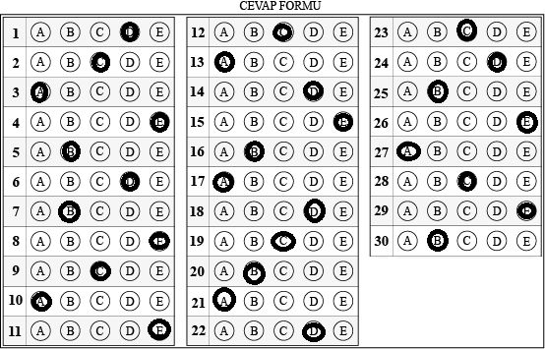

|  |  |  |
| --- | --- | --- |
| Cevap Anahtarı | | |
| Soru | Cevap | Slayt Numarası |
| 1 | D | 3 |
| 2 | C | 4 |
| 3 | A | 7 |
| 4 | E | 10 |
| 5 | B | 11 |
| 6 | D | 13 |
| 7 | B | 14-16 |
| 8 | E | 19 |
| 9 | C | 20 |
| 10 | A | 22 |
| 11 | E | 23 |
| 12 | C | 25-26 |
| 13 | A | 27 |
| 14 | D | 30 |
| 15 | E | 34 |
| 16 | B | 35 |
| 17 | A | 36 |
| 18 | D | 39 |
| 19 | C | 40 |
| 20 | B | 43 |
| 21 | A | 44 |
| 22 | D | 50 |
| 23 | C | 49 |
| 24 | D | 54 |
| 25 | B | 50 |
| 26 | E | 52 |
| 27 | A | 54 |
| 28 | C | 59 |
| 29 | E | 62 |
| 30 | B | 33 |